**PIZZA SALES SQL QUERIES**

**A. KPI’s**

--**1. Total Revenue:**

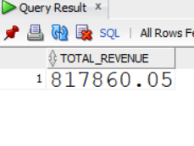select sum(total_price) as TOTAL_REVENUE from pizza_sales;

**2. Average Order Value**

select round((sum(total_price) / count(distinct(order_id))),2) as avg_order_value from pizza_sales;

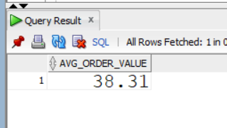

**3. Total Pizzas Sold**

select sum(ps.quantity)as pizzas_sold from pizza_sales ps;

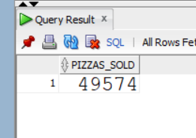

**4. Total Orders**

select count(distinct(order_id))as total_orders from pizza_sales ps;

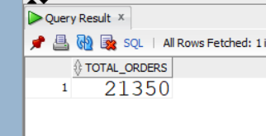

**5. Average Pizzas Per Order**

select round(sum(ps.quantity)/count(distinct(order_id)),2) as avg_pizza_per_order from pizza_sales ps;

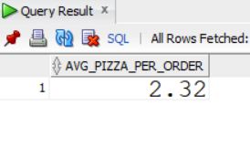

**B. Hourly Trend for Total Pizzas Sold**

SELECT TO_CHAR(TO_DATE(order_time, 'HH24:MI:SS'), 'HH24') AS ORDER_IN_HOURS,

SUM(quantity) as total_pizzas_sold

FROM pizza_sales

GROUP BY TO_CHAR(TO_DATE(order_time, 'HH24:MI:SS'), 'HH24')

ORDER BY TO_CHAR(TO_DATE(order_time, 'HH24:MI:SS'), 'HH24');

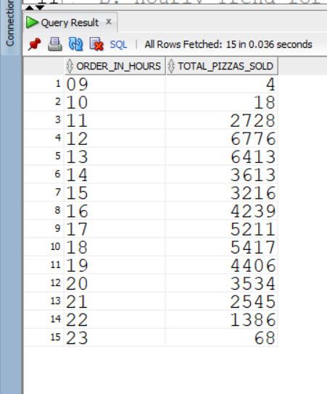

**C. Weekly Trend for Orders**

SELECT

TO_CHAR (order_date, 'IW') AS WeekNumber, -- ISO week number

TO_CHAR (order_date, 'YYYY') AS Year, -- Year

COUNT (DISTINCT order_id) AS Total_orders

FROM

pizza_sales

GROUP BY

TO_CHAR(order_date, 'IW'), -- Group by ISO week number

TO_CHAR (order_date, 'YYYY’) -- Group by year

ORDER BY

TO_CHAR (order_date, 'YYYY');

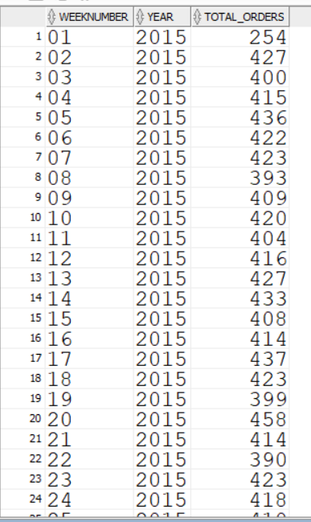 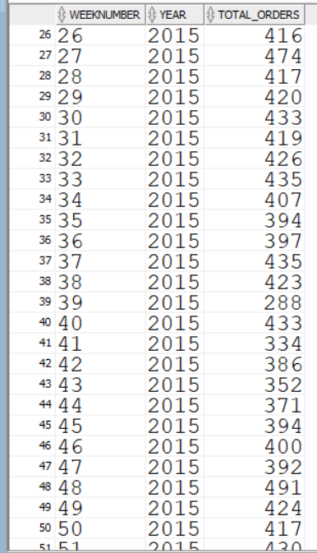

**D. % of Sales by Pizza Category**

SELECT pizza_category, ROUND (SUM (total_price),2) as total_revenue,

ROUND (SUM (total_price) * 100 / (SELECT SUM (total_price) from pizza_sales),2) AS Per_cent

FROM pizza_sales

GROUP BY pizza_category;

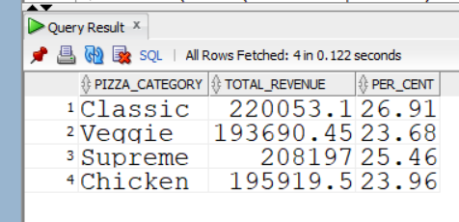

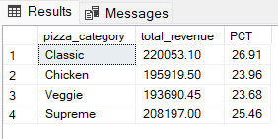

**E. % of Sales by Pizza Size**

select pizza_size,sum(total_price)as total_sales,

round(sum(total_price)*100/(select sum(total_price)from pizza_sales),2)as per_cent_of_sales from pizza_sales

group by pizza_size

ORDER BY pizza_size;

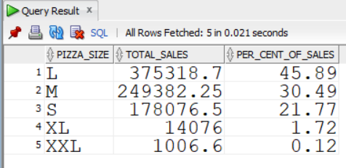

**F. Total Pizzas Sold by Pizza Category**

select pizza_category, sum(quantity)as total_pizzas_sold from pizza_sales

group by pizza_category

order by total_pizzas_sold desc;

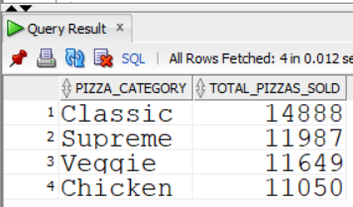

**G. Top 5 Pizzas by Revenue**

SELECT pizza_name, SUM(total_price) AS Total_Revenue

FROM pizza_sales

GROUP BY pizza_name

ORDER BY Total_Revenue DESC

FETCH first 5 rows only;

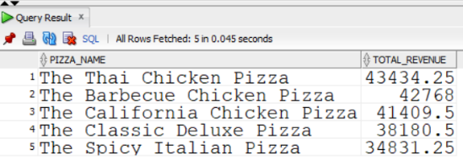

**H. Bottom 5 Pizzas by Revenue**

SELECT pizza_name, SUM(total_price) AS Total_Revenue

FROM pizza_sales

GROUP BY pizza_name

ORDER BY Total_Revenue ASC

FETCH first 5 rows only;

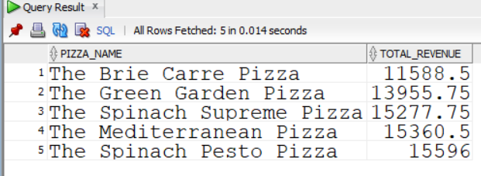

**I. Top 5 Pizzas by Quantity**

SELECT pizza_name, SUM(quantity) AS Total_Pizza_Sold

FROM pizza_sales

GROUP BY pizza_name

ORDER BY Total_Pizza_Sold DESC

FETCH first 5 rows only;

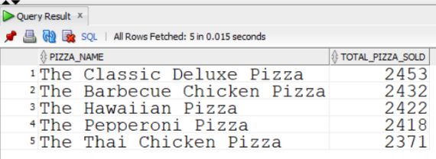

**J. Bottom 5 Pizzas by Quantity**

SELECT pizza_name, SUM(quantity) AS Total_Pizza_Sold

FROM pizza_sales

GROUP BY pizza_name

ORDER BY Total_Pizza_Sold ASC

FETCH first 5 rows only;

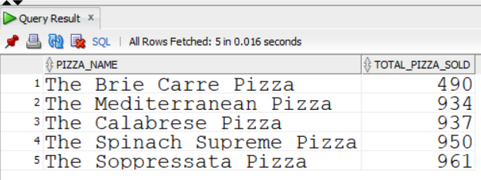

**K. Top 5 Pizzas by Total Orders**

SELECT pizza_name, COUNT(DISTINCT order_id) AS Total_Orders

FROM pizza_sales

GROUP BY pizza_name

ORDER BY Total_Orders DESC

FETCH first 5 rows only;

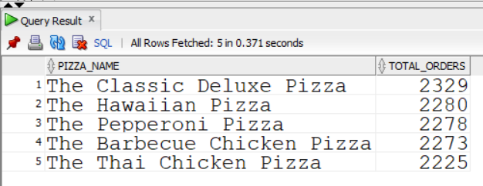

**L. Borrom 5 Pizzas by Total Orders**

SELECT pizza_name, COUNT(DISTINCT order_id) AS Total_Orders

FROM pizza_sales

GROUP BY pizza_name

ORDER BY Total_Orders

FETCH first 5 rows only;

